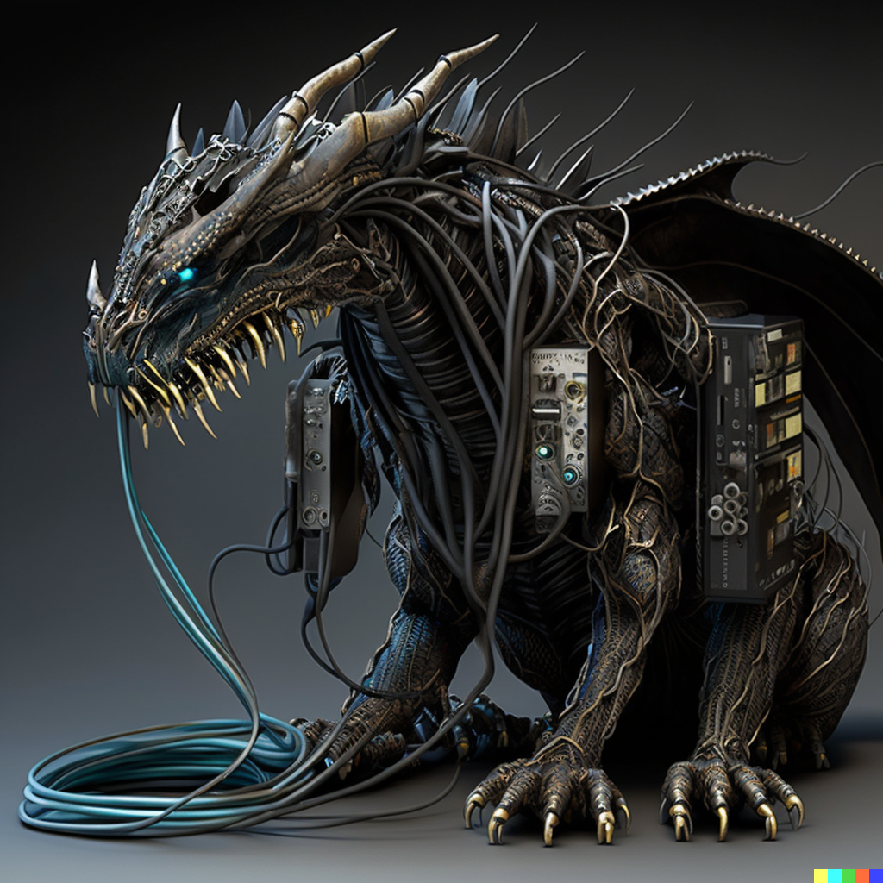

**Only Three Colours**

**Genres**  
  
  
  
Action RPG